# Physics Overrides

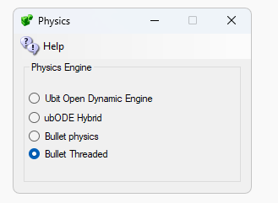

* UBODE is closer to Second Life in vehicle performance. However, it does not properly work with a mesh without a physics model. Instead of using the visible model, it uses supports convex hull. As a result, some mesh things that have holes, such as house and doorway will not let you walk in them.
* BulletSim is an Academy Award winning physics engine that provides the best performance on collisions. It makes a physics model from the mesh visible look when there is no physics mesh.
* Bullet Threaded run physics in a separate. This prevents possible physics crashes from crashing the region. It is the default physics engine.